

**BOARD OF TRUSTEES**

**Eva C. Watts**

President

**Dr. Maricela Valdez** Vice-President

**Lieutenant Colonel (R)****Roberto Perez**

Secretary

**Members**

David De Los Rios Valentin Guerrero Dr. Donna Mery Alicia Reyna

**ADMINISTRATION**

**Dr. Hafedh Azaiez** Superintendent

**Dr. Anthony J. Sorola** Assistant Superintendent for Human Resources

**Dr. Debra A. Aceves**

Assistant Superintendent for Leadership

**Velma Rangel** Assistant Superintendent of District Operations

**Rashad J. Rana**

Assistant Superintendent of Curriculum and Instruction

**Ludivina A. Cansino**

Assistant Superintendent of Business and Finance

Parental involvement plays a large factor in early childhood student success. In order to support parents and provide them with ideas and strategies to support their child’s literacy achievement, DISD hosted the following series of sessions for parents during the 2020-2021 school year.

These sessions were developed around materials from “Partners in Print,” a parent-involvement program for beginning readers. The aim of this program is to educate and empower parents so they can help develop their children’s literacy and encourage partnership between parents, teachers, and children.

The dates and times for the 2020-2021 school year were as follows (some campuses made adjustments to the dates and still covered the topics). The hours for the sessions were 5:30-6:30 p.m. at each respective campus.

* September 24th – Opening Night (Program Introduction), 5:30 p.m.-6:30 p.m.
* November 5th – Build Self-Esteem
* December 10th – Drawing Meaning from Text
* February 4th – Playing with Print
* March 11h – Conventions of Print (Canceled due to school closure)
* April 15th – Writing (Canceled due to school closure)
* May 13th – Grand Finale (Canceled due to school closure)

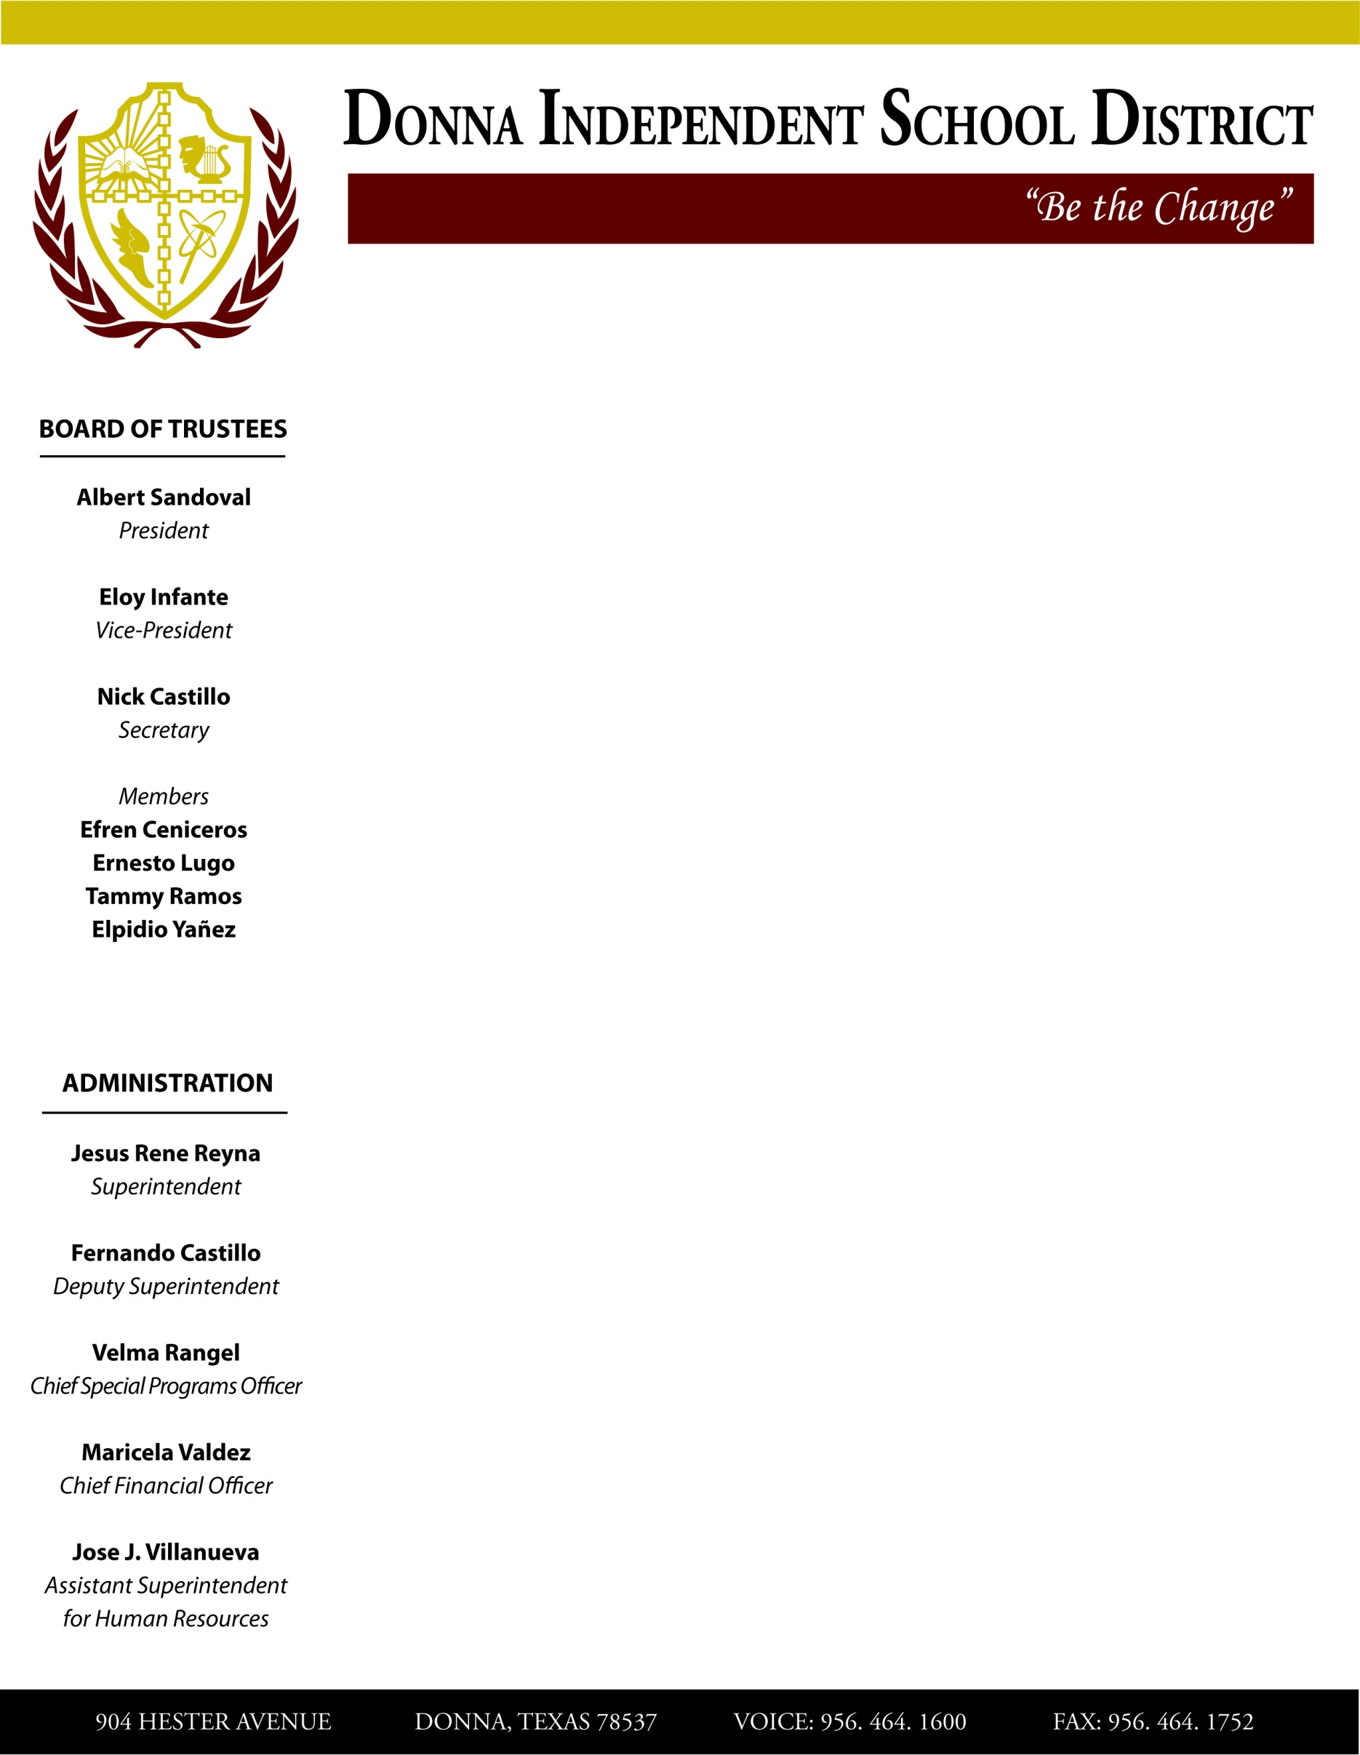

904 HESTER AVENUE DONNA, TEXAS 78537 VOICE: 956-464-1600 FAX: 956-464-17522